**DIGITAL MARKETING**

**ASSIGNMENT :1**

|  |  |
| --- | --- |
| Name | Beni jeshna.A |
| Reg No | 960220106040 |
| NM ID | 9312E1300E841E2AF494DABBE39822A5 |
| Team ID | NM2023TMIDO2667 |

Create a blog or website using Blogspot and WordPress.  
Customize the theme design and post new article with 500  
words.

**BLOGSPOT: https://www.blogger.com/blog/post/edit/4660395219766722809/7074584997340489281**

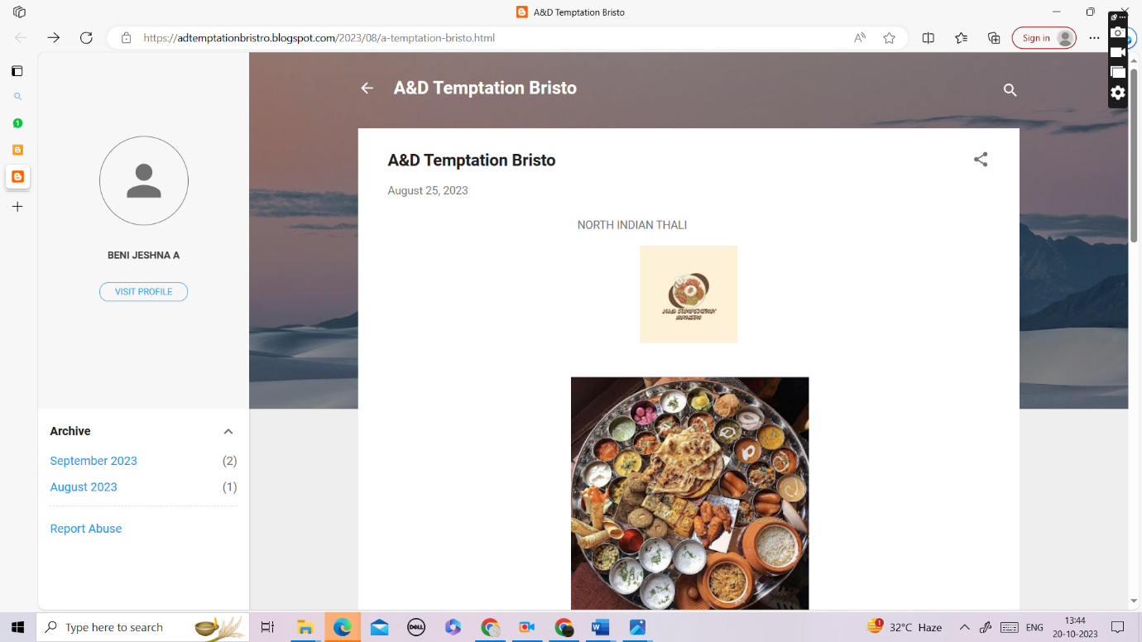

WordPress: https://temptationbistro.wordpress.com/2023/10/13/ad-temptation-bistro/

